# GCC Debugger setup in VS Code

1. Open C file in VS Code
2. Set breakpoint in code
3. Press F5 or select Start debugging from Debug menu  
   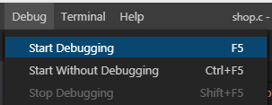
4. Select C++(GDB/LLDB) from popup  
   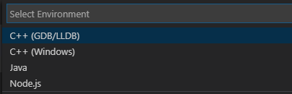
5. Then select gcc.exe build and debug active file  
   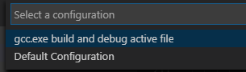
6. The Launch.json window should now pop up, see that this has the right path to your gdb.exe file, save and close.  
   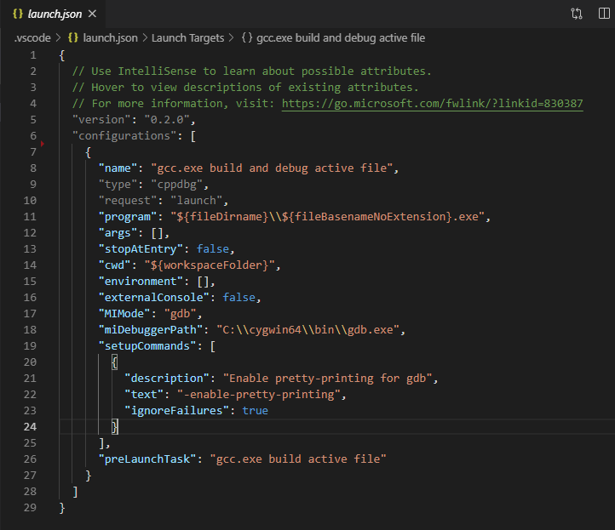
7. G back to the C file and F5 again, ow it should pop up a message about not being able to build the active file, click “Configure Task”.  
   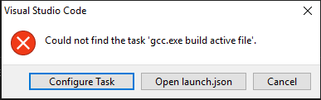
8. Select C/C++:gcc.exe build active file
9. Now the task,json file should pop up and confirm that “command” points to the right location where the gcc.exe file is located. Save and close  
   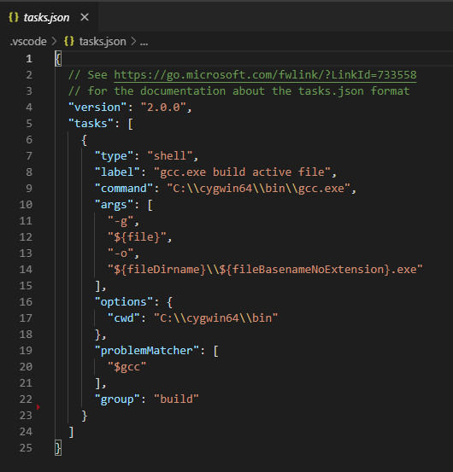
10. Go back to the C file again and press F5.
11. Now everything should start up and the code should stop at the debugger breakpoint.  
    